LIST OF FIGURES

Figure No. | Figure Name | Page No.
4.1 | ER Diagram | 8
4.2 | Schema Diagram | 9
5.1 | Account table description | 10
5.2 | Student table description | 10
5.3 | Teacher table description | 11
5.4 | Attendance_student table description | 11
5.5 | Attendance_teacher table description | 12
5.6 | Subject table description | 12
5.7 | Marks table description | 13
5.8 | Fee table description | 13
9.1 | Login Page | 24
9.2 | Signup Page | 24
9.3 | Home Page | 25
9.4 | Student Page | 25
9.5 | Teacher Page | 26
9.6 | Subject Page | 26
9.7 | Fee Page | 27

LIST OF TABLES

TABLE NO. | DESCRIPTION | PAGE NO.
1.1 | Account Table | 14
1.2 | Student Table | 14
1.3 | Teacher Table | 15
1.4 | Attendance_Student Table | 15
1.5 | Attendance_Teacher Table | 16
1.6 | Subject Table | 16
1.7 | Marks Table | 17
1.8 | Fee Table | 17
1.9 | Test Cases | 23

CHAPTER 1

  - Overview:

INTRODUCTION

UNIVERSITY MANAGEMENT SYSTEM (UMS) is a flagship product of Easy Solution which covers all aspects of Universities, Colleges or Schools. UMS covers every minute aspects of a universities work flow and integrates all processes with user friendly interface. With hundreds of satisfied customers UMS is first choice of several state, governments/semi- government universities and institutions. UMS is an outcome of hard work done by our expert technical team in supervision of several renowned educationists which includes Controller of examination, faculties. UMS is a rare combination of experience and precision. UMS streamline path of information flow in organization by taking care of following departments:
    - Fee Department
    - Examination Department
    - Attendance
    - Faculty information portal
    - Student information portal

Purpose:
    - Drive operational efficiency.
    - Self-service systems with simple to use with little or no training.
    - Elimination of duplicate data entry processes.
    - Integrated with Online Application workflow with unified data model.
    - Monitoring and decision support system.
    - Automation of all the Academic / Examination / Administration operations.
    - Ease and accuracy of reporting.

  - Scope:
This project deals with the various functioning in College management process. The main idea is to implement a proper process to system. In our existing system contains a many operations registration, student search, fees, attendance, exam records, performance of the student etc. All these activity takeout manually by administrator.

CHAPTER 2

REQUIREMENT SPECIFICATIONS

Hardware Requirements :

Processor Brand | : Intel
Processor Type | : Core i3
Processor Speed | : 2 GHz
Processor Count | : 1
RAM Size | : 2 GB
Memory Technology | : DDR3
Computer Memory Type | : DDR3 SDRAM
Hard Drive Size | : 160 GB

  - Software Requirements :

Operating system : Windows 10

Application server : JAVA (NetBeans)

Front end : JAVA

Connectivity : JDBC Driver

Database connectivity : WAMP (MYSQL Console)

CHAPTER 3

TOOL DESCRIPTION

Overview of Front End

An important issue for the development of a project is the selection of suitable front- end and back-end. When we decided to develop the project we went through an extensive study to determine the most suitable platform that suits the needs of the organization as well as helps in development of the project.
The aspects of our study included the following factors. Front-end selection:
- It must have a graphical user interface that assists employees that are not from IT background.
- Scalability and extensibility.
- Flexibility.
- Robustness.
- According to the organization requirement and the culture.
- Must provide excellent reporting features with good printing support.
- Platform independent.
- Easy to debug and maintain.
- Event driven programming facility.
- Front end must support some popular back end like MySQL.
According to the above stated features we selected PHP and CSS as the front-end for developing.

About Java:

Java is a general-purpose, class-based, object-oriented programming language designed for having lesser implementation dependencies. It is a computing platform for application development. Java is fast, secure, and reliable, therefore. It is widely used for developing Java applications in laptops, data centers, game consoles, scientific supercomputers, cell phones, etc.

Here are some important Java applications:

      - It is used for developing Android Apps
      - Helps you to create Enterprise Software
      - Wide range of Mobile java Applications
      - Scientific Computing Applications
      - Use for Big Data Analytics
      - Java Programming of Hardware devices
      - Used for Server-Side Technologies like Apache, JBoss, GlassFish, etc.

Overview of Back End
Back End Selection:
- Multiple user support.
- Efficient data handling.
- Provide inherent features for security.
- Efficient data retrieval and maintenance.
- Stored procedures.
- Popularity.
- Operating System compatible.
- Easy to install.
- Various drivers must be available.
- Easy to implant with the Front-end.
According to above stated features we selected MySQL as the backend.
The technical feasibility is frequently the most difficult area encountered at this stage. It is essential that the process of analysis and definition be conducted in parallel with an assessment to technical feasibility. It centers on the existing computer system (hardware, software etc.) and to what extent it can support the proposed system.

About SQL:

SQL is Structured Query Language, which is a computer language for storing, manipulating and retrieving data stored in a relational database.

SQL is the standard language for Relational Database System. All the Relational Database Management Systems (RDMS) like MySQL, MS Access, Oracle, Sybase, Informix, Postgres and SQL Server use SQL as their standard database language.
MySQL is a fast, easy-to-use RDBMS being used for many small and big businesses. MySQL is developed, marketed and supported by MySQL AB, which is a Swedish company. MySQL is becoming so popular because of many good reasons.[1]
MySQL is released under an open-source license. So you have nothing to pay to use it. MySQL is a very powerful program in its own right. It handles a large subset of the functionality of the most expensive and powerful database packages. MySQL uses a standard form of the well-known SQL data language. MySQL works on many operating systems and with many languages including PHP, PERL, C, C++, JAVA, etc.
MySQL works very quickly and works well even with large data sets. MySQL is very friendly to PHP, the most appreciated language for web development. MySQL supports large databases, up to 50 million rows or more in a table. The default file size limit for a table is 4GB, but you can increase this (if your operating system can handle it) to a theoretical limit of 8 million terabytes (TB).
Also, they are using different dialects, such as −

- Oracle using PL/SQL,.
- SQL is widely popular because it offers the following advantages −
- Allows users to access data in the database management systems.
- Allows users to describe the data.relational
- Allows users to define the data in a database and manipulate that data.
- Allows to embed within other languages using SQL modules, libraries & pre-compilers.
- Allows users to create and drop databases and tables.
- Allows users to create view, stored procedure, functions in a database.
- Allows users to set permissions on tables, procedures and views.

CHAPTER 4

REQUIREMENT ANALYSIS

E-R DIAGRAM:

ER Diagram: ER Diagram is a high-level conceptual data model diagram. Entity-Relation model is based on the notion of real-world entities and the relationship between them. ER modelling helps you to analyse data requirements systematically to produce a well-designed database.

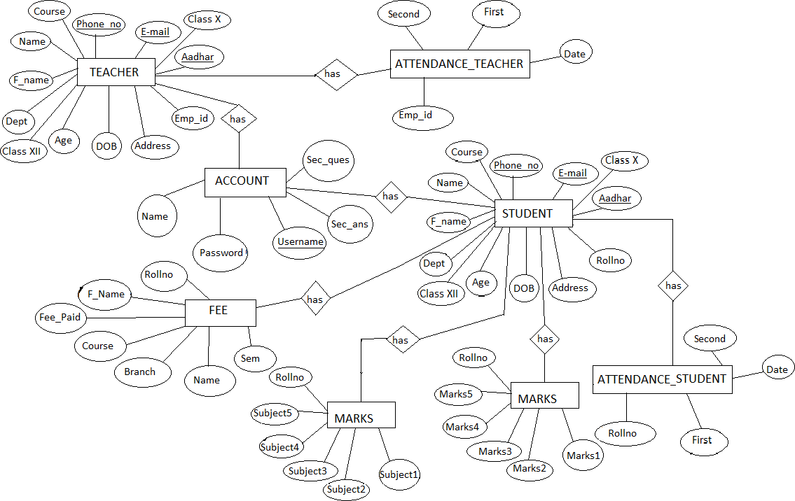

Figure 4.1: ER Diagram for Smartphone Management Arena

SCHEMA DIAGRAM:

Schema diagram A schema diagram is the skeleton structure that represents the logical view of the entire database. It contains a descriptive detail of the database.

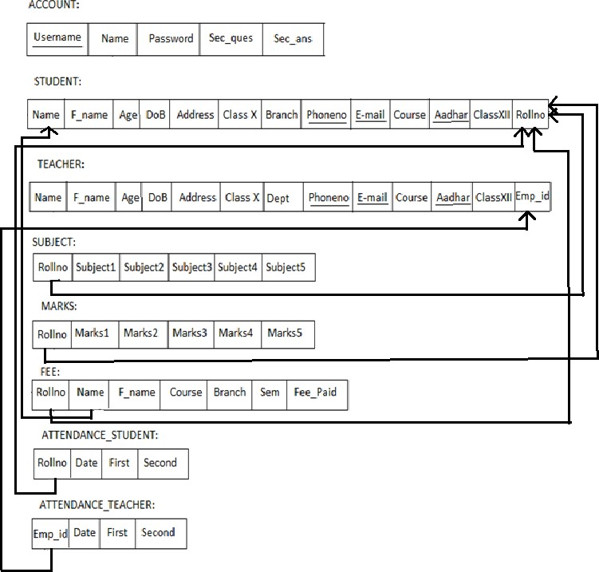
Figure 4.2: Schema Diagram for Smartphone Management System

CHAPTER 5

TABLE DESCRIPTION

5.1 Database Design

ACCOUNT TABLE

Account Table: Account table consists of five attributes which are Username, Name, Password, Sec_ques, Sec_ans.Username is used as Primary key.
Desc account;
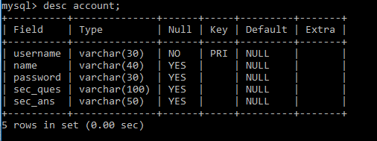

Fig 5.1 Account table description
STUDENT TABLE

Student table :Student table is used to add the details of new student like Name,phoneno.,DoB,course,Branch etc...Phoneno. ,E-mail and Aadhar are used as Primary key.
Desc student;
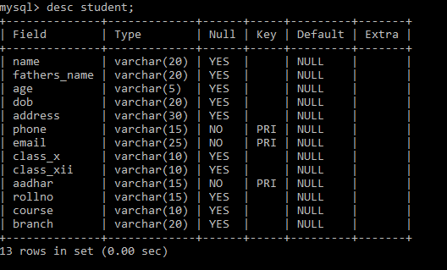

Fig 5.2 Student table description.

TEACHER TABLE
Teacher table: Teacher table is used to add the details of new student like Name, phoneno.,DoB, course,Branch etc...Phoneno. ,E-mail and Aadhar are used as Primary key.
Desc teacher;
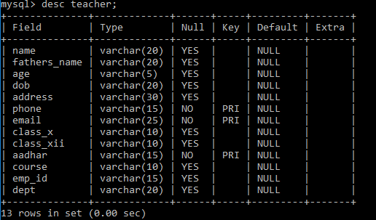

Fig 5.3 Teacher table description

ATTENDANCE_STUDENT TABLE

Attendance_Student Table: Attendance_Student table is used to mark the attendance of the student day to day which as attributes like rollno,name,first and second half.
Desc attendance_student;
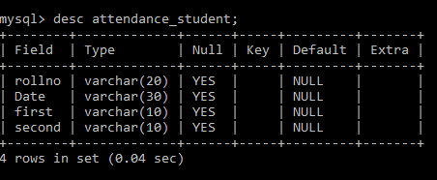

Fig 5.4 Attendance_Student table description.

ATTENDANCE_TEACHER TABLE

Attendance_Teachertable :Attendance_Teacher table is used to mark the attendance of the teacher day to day which as attributes like emp_id,name,first and second half.
Desc attendance_teacher;
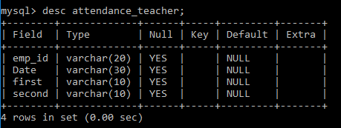

Fig 5.5 Attendance_Teacher table description.

SUBJECT TABLE

Subject table :Subject table is used to add the subjects of the student in that particular sem with the attributes like rollno and five subjects.
Desc Subject;
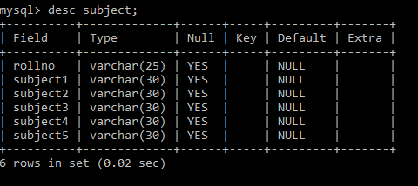

Fig 5.6 Subject table description.

MARKS TABLE

Marks table :Marks table is used to add the marks of the particular subjects of the student in a particular sem and the attributes used are rollno and five subject marks.
Desc Marks;

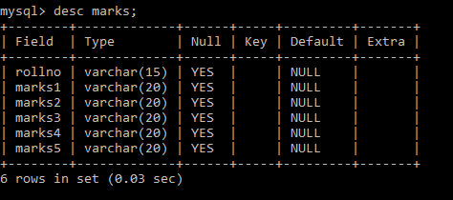

Fig 5.7 Marks table description.

FEE TABLE

Fee table:fee table is used to pay the fee dues of the student for that particular sem and the attributes used like rollno, name, fathersname, course, branch, sem and fee_paid.
Desc Fee;

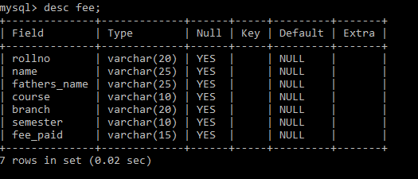
Fig 5.8 Fee table description.

CHAPTER 6

TABLE WITH VALUES

6.1 Output design:

Account table :Account table consists of five attributes which will be retrived from user when the user signsup/logs in.
Select * from account;

Table 1.1 Account table
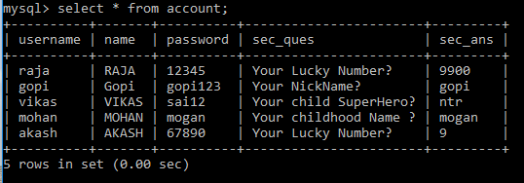
Student table: Student table is used to add the details of new student like Name,phoneno.,DoB,course,Branch etc...Phoneno.E-mail and Aadhar are used as Primary key.
Select * from student;

Table 1.2 Student table
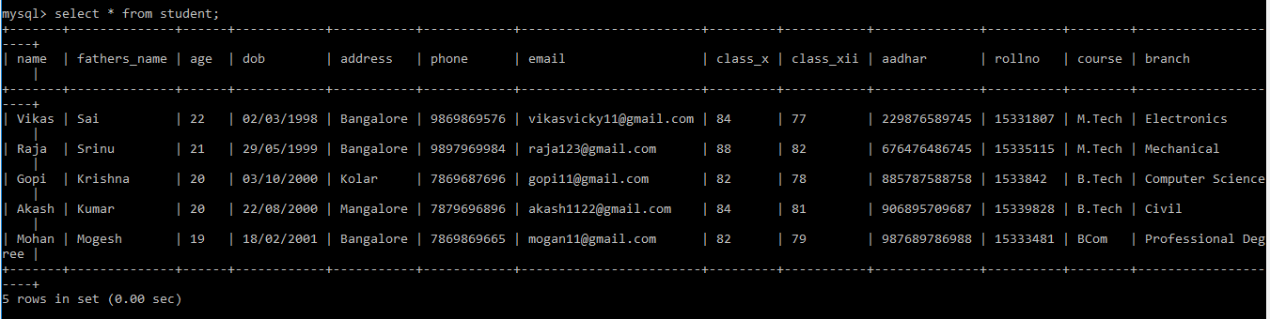

Teacher table :Teacher table is used to add the details of new student like Name,phoneno.,DoB,course,Branch etc...Phoneno. ,E-mail and Aadhar are used as Primary key.
Select * from teacher;

Table 1.3 Teacher table
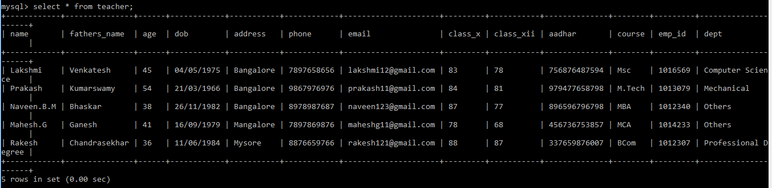

Attendance_Student table :Attendance_Student table is used to mark the attendance of the student day to day which as attributes like rollno,name,first and second half.
Select * from attendance_student;

Table 1.4 Attendance_student table
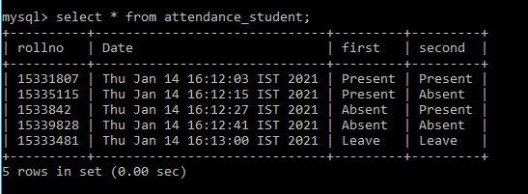

Attendance_Teacher table :Attendance_Teachertable is used to mark the attendance of the teacher day to day which as attributes like emp_id,name,first and second half.
Select * fromattendance_teacher;

Table 1.5 Attendance_teacher table
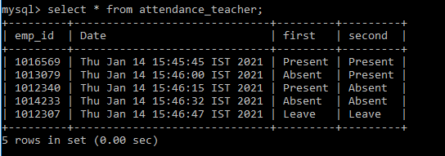

Subject table : Subject table is used to add thesubjects of the student in that particular sem with the attributes like rollno and five subjects.
Select * from Subject;

Table 1.6 Subject table
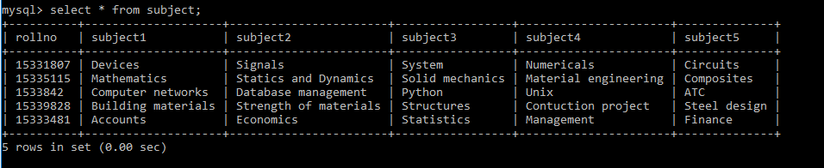

Marks table :Markstable is used to add the marks of the particular subjects of the student in a particular sem and the attributes used are rollno and five subject marks.
Select * from Marks;

Table 1.7 Marks table
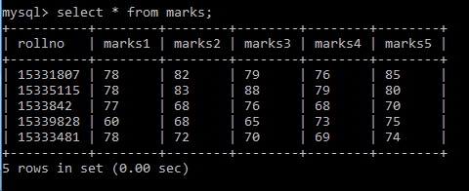

Fee table :fee table is used to pay the fee dues of the student for that particular sem and the attributes used like rollno, name, fathersname, course, branch, sem and fee_paid.
Select * from Fee;

Table 1.8 Fee table
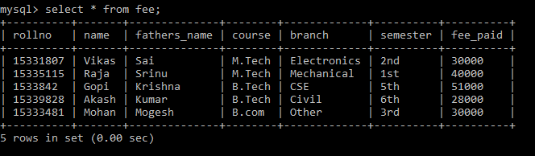

CHAPTER 7

Sample code :

IMPLEMENTATION

Package institution.management.system; importjava.awt.*;
importjavax.swing.*; importjava.awt.event.*; importjava.sql.*;
importinstitution.management.system.Signup;

public class Login extends JFrame implements ActionListener{ privateJPanel panel;
privateJTextFieldtextField; privateJPasswordFieldpasswordField;
privateJButton b1,b2,b3;

public Login() {

setBackground(new Color(169, 169, 169));

setBounds(600, 300, 600, 400);

panel = new JPanel();

panel.setBackground(new Color(176, 224, 230)); setContentPane(panel);
panel.setLayout(null);

JLabel l1 = new JLabel("Username : "); l1.setBounds(124, 89, 95, 24);

panel.add(l1);

JLabel l2 = new JLabel("Password : "); l2.setBounds(124, 124, 95, 24); panel.add(l2);
textField = new JTextField(); textField.setBounds(210, 93, 157, 20); panel.add(textField);
passwordField = new JPasswordField(); passwordField.setBounds(210, 128, 157, 20); panel.add(passwordField);
JLabel l3 = new JLabel(""); l3.setBounds(377, 79, 46, 34); panel.add(l3);
JLabel l4 = new JLabel(""); l4.setBounds(377, 124, 46, 34); panel.add(l3);
b1 = new JButton("Login"); b1.addActionListener(this); b1.setForeground(new Color(46, 139, 87));
b1.setBackground(new Color(250, 250, 210));

b1.setBounds(149, 181, 113, 39); panel.add(b1);
b2 = new JButton("SignUp"); b2.addActionListener(this);

b2.setForeground(new Color(139, 69, 19));

b2.setBackground(new Color(255, 235, 205));

b2.setBounds(289, 181, 113, 39); panel.add(b2);
b3 = new JButton("Forgot Password"); b3.addActionListener(this);
b3.setForeground(new Color(205, 92, 92));

b3.setBackground(new Color(253, 245, 230));

b3.setBounds(199, 231, 179, 39); panel.add(b3);
JLabel l5 = new JLabel("Trouble in Login?"); l5.setFont(new Font("Tahoma", Font.PLAIN, 15)); l5.setForeground(new Color(255, 0, 0));
l5.setBounds(70, 240, 130, 20); panel.add(l5);
JPanel panel2 = new JPanel(); panel2.setBackground(new Color(176, 224, 230));
panel2.setBounds(24, 40, 434, 263); panel.add(panel2);
}

public void actionPerformed(ActionEventae){ if(ae.getSource() == b1){
Boolean status = false; try {

conn con = new conn();

String sql = "select * from account where username=? and password=?"; PreparedStatementst = con.c.prepareStatement(sql);
st.setString(1, textField.getText()); st.setString(2, passwordField.getText()); ResultSetrs = st.executeQuery();
if (rs.next()) { this.setVisible(false);
new Loading().setVisible(true);

} else

JOptionPane.showMessageDialog(null, "Invalid Login...!.");

} catch (Exception e2) { e2.printStackTrace();} } if(ae.getSource() == b2){ setVisible(false);
Signup su = new Signup(); su.setVisible(true);}
if(ae.getSource() == b3){ setVisible(false);
ForgotPassword forgot = new ForgotPassword(); forgot.setVisible(true);}
}

public static void main(String[] args) {

new Login().setVisible(true); } }

CHAPTER 8
TESTING

System testing is the stage of implementation, which is aimed at ensuring that the system works accurately and efficiently before live operation commences. Testing is the process of executing the program with the intent of finding errors and missing operations and also a complete verification to determine whether the objectives are met and the user requirements are satisfied. The ultimate aim is quality assurance.

Unit Testing

The software units in a system are modules and routines that are assembled and integrated to perform a specific function. Unit testing focuses first on modules, independently of one another, to locate errors. This enables, to detect errors in coding and logic that are contained within each module. This testing includes entering data and ascertaining if the value matches to the type and size supported by java. The various controls are tested to ensure that each performs its action as required.

Integration Testing

Data can be lost across any interface, one module can have an adverse effect on another, sub functions when combined, may not produce the desired major functions. Integration testing is a systematic testing to discover errors associated within the interface. The objective is to take unit tested modules and build a program structure. All the modules are combined and tested as a whole. Here the Server module and Client module options are integrated and tested. This testing provides the assurance that the application is well integrated functional unit with smooth transition of data.

User Acceptance

Testing User acceptance of a system is the key factor for the success of any system. The system under consideration is tested for user acceptance by constantly keeping in touch with the system users at time of developing and making changes whenever required.

Test Cases:

Table 1.9 Test cases

Test No. | Test Name | input | Actual output | Expected output | Status
1 | Login | Username and password | User is  successfully Authenticated | User is  successfully Authenticated | Pass
2 | Login | Wrong username and  password | Invalid username or  password | Invalid username or  password | Pass
3 | Signup | User details and  passsword | Account successfully  created | Account successfully  created | Pass
4 | Student | Details of the  student required. | Student  inserted successfully | Student  inserted successfully | Pass
5 | Teacher | Details of the  teacher required | Teacher  inserted successfully | Teacher  inserted successfully | Pass
6 | Subject | Enter the subject names and marks along with  rollno | Subjects entered successfully | Subjects entered successfully | Pass
7 | Fee | Details and fee_paid | Paid successfully | Paid successfully | Pass
8 | Remove Student | Enter rollno and click on  remove | Removed successfully | Removed successfully | Pass
9 | Remove Teacher | Enter emp_id and click on  remove | Teacher removed  successfully | Teacher removed  successfully | Pass
10 | Exit | Click on Exit | Logout successfully | Logout successfully | Pass

CHAPTER 9

SNAPSHOTS

- Login form: This page represents the first thing about our website. It leads on to the login point for its personnel; it takes up the username,password and signup.
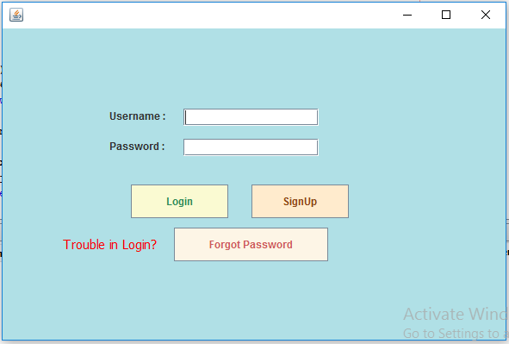

Figure 9.1: Login form

- Signup page: This page represents signing up to website. It leads to registering to website making username and password, it takes the up username, name, password and security question. These information are mandatory.
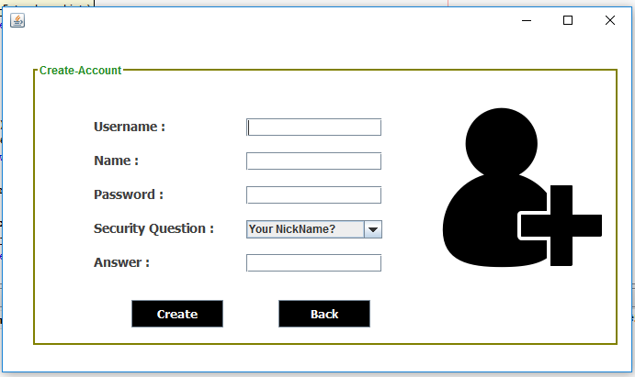

Figure 9.2: Signup page

- Home page user : This page shows us what user can see and access. He can add, remove,update and upload the data. He can logout from the website in homepage.


Figure 9.3: Home page user

- Student form : In this we can add the new student details which will be stored in back end of user.This details further can updated in the update page.
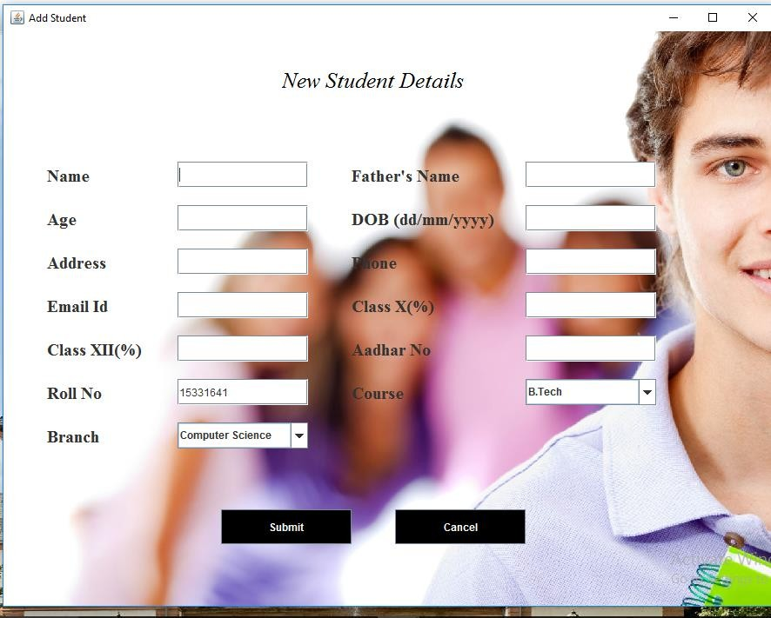

Figure 9.4: Student form

- Teacher form: In this we can add the new teacher details which will be stored in back end of user.This details further can updated in the update page.

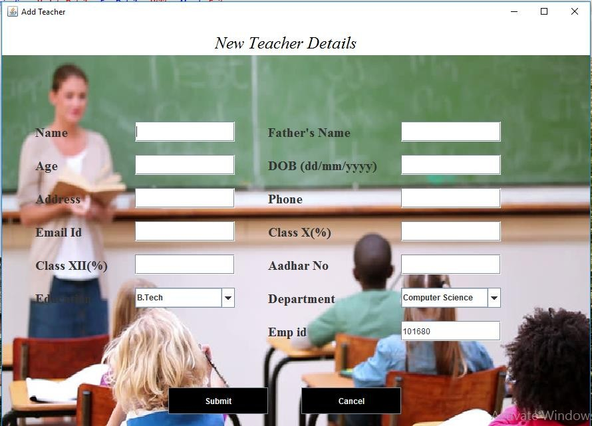

Figure 9.5: Teacher form

- Marks and Subject page : In this page we can enter the subjects and marks scored in that particular subject along the rollno.

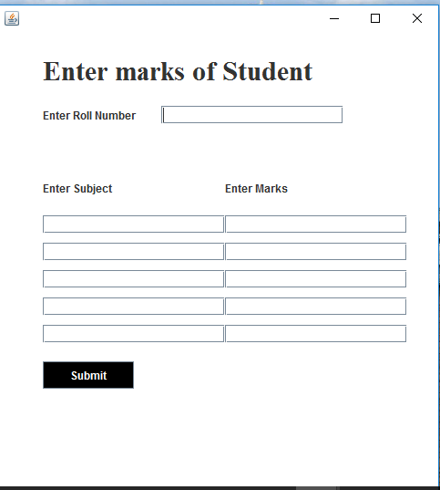

Figure 9.6: Marks and Subject page

- Fee payment page : In this page we can the pay the fee dues of the particular student which uses rollno,course,branch and sem to pay the fee.

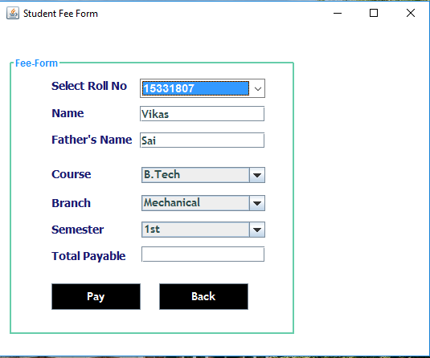
Figure 9.7: Fee payment page

CONCLUSION

The project entitled as Institution Management System is the system that deals with the issues related to a particular institution.
This project is successfully implemented with all the features mentioned in system requirements specification.
The application provides appropriate information to users according to the chosen service.
The project is designed keeping in view the day to day problems faced by a college.

Deployment of our application will certainly help the college to reduce unnecessary wastage of time in personally going to each department for some information.
Awareness and right information about any college is essential for both the development of student as well as faculty. So this serves the right purpose in achieving the desired requirements of both the communities.

REFERENCES

Books and Websites:

- Internet & World Wide Web: How to Program Deitel, PJ Deitel.
- Code for Interview YouTube Channel.
- Database System Concepts, by Silberschatz, Sudarshan, and Korth.
- Fundamentals of Database Systems, RamezElmasri and Shamkant B. Navathe, 7th Edition. 2017, Pearson...

